# Dauen Zhadyra Berikkyzy. 21B030797

# Assignment 1, Cloud Application Development

Put all deliverables into github repository in your profile. Share link to google form 24 hours before defense. Defend by explaining deliverables and answering questions. Deliverables: report in pdf Google form: [https://docs.google.com/forms/d/e/1FAIpQLSe0GyNdOYlvM1tX_I_CtlPod5jBf-ACLGdHYZq1gV ZbUeBzIg/viewform?usp=sf_link](https://docs.google.com/forms/d/e/1FAIpQLSe0GyNdOYlvM1tX_I_CtlPod5jBf-ACLGdHYZq1gVZbUeBzIg/viewform?usp=sf_link)

# Exercise 1: Setting Up Google Cloud SDK

1. **Objective**: Install and configure the Google Cloud SDK on your local machine.
2. **Steps**:
   1. Visit the Google Cloud SDK installation page.

○ Follow the instructions to download and install the SDK for your operating system.

○ After installation, run gcloud init to initialize the SDK and authenticate with your Google account.

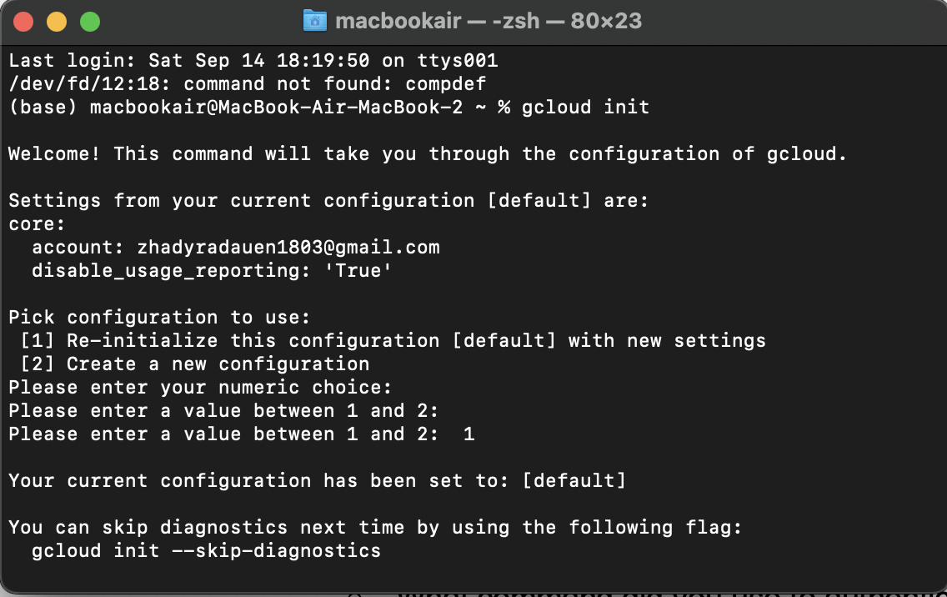

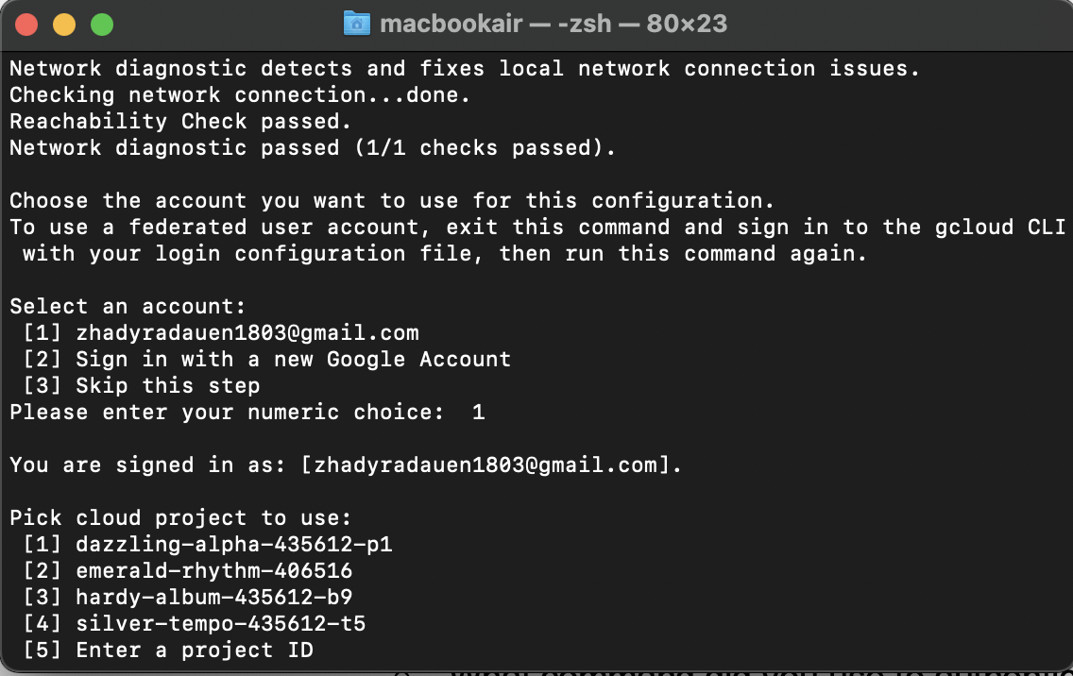

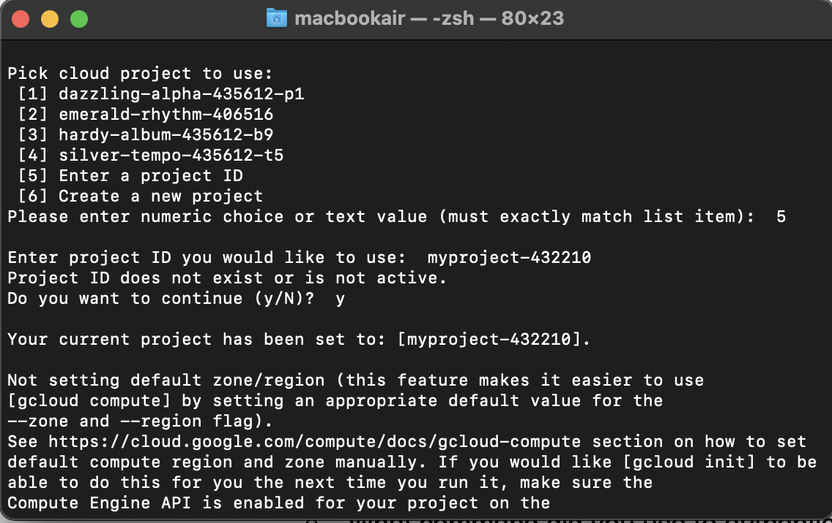

○ Configure the default project and region.

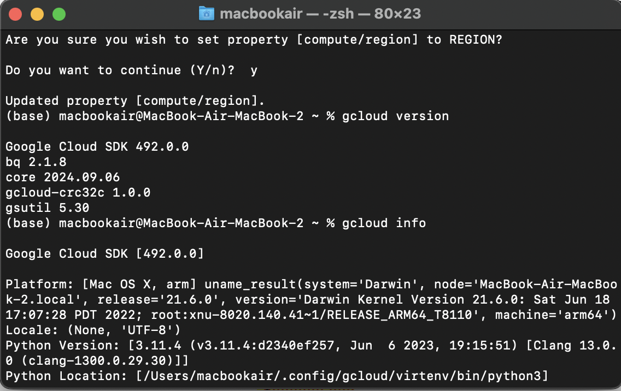

○ Verify the installation by running gcloud version and gcloud info.

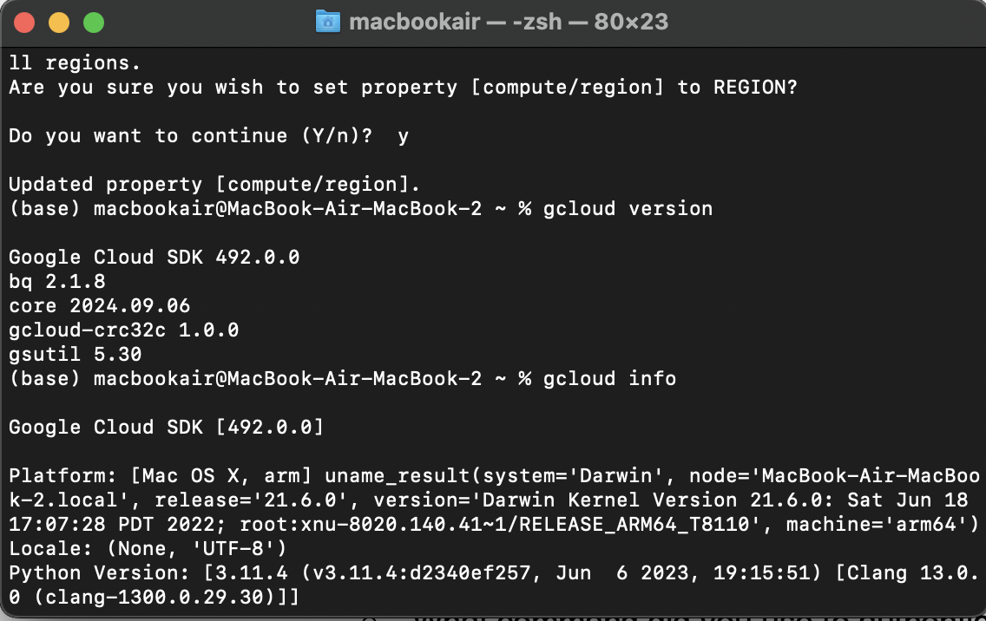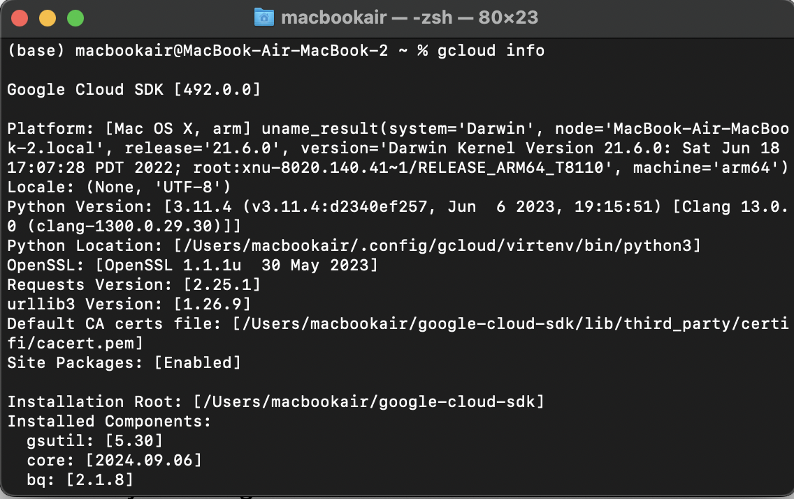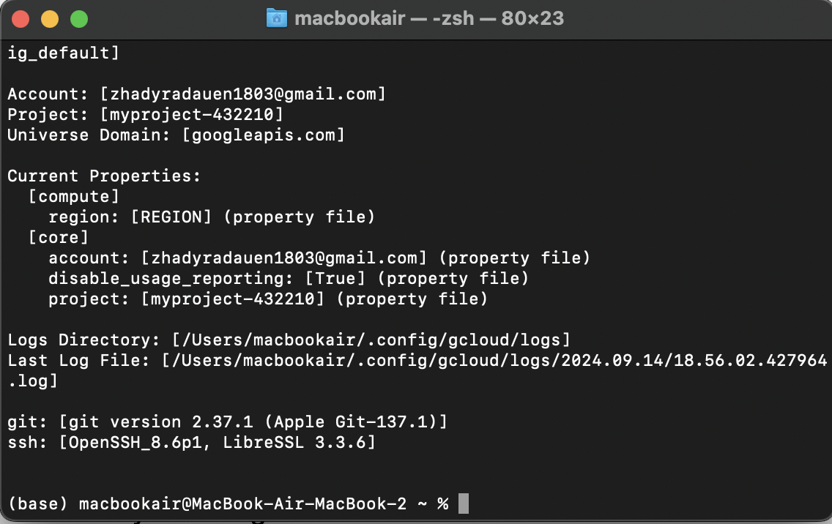

1. **Questions**:
   1. What command did you use to authenticate with your Google account?

gcloud init

○ How did you set the default project?

gcloud config set project myproject-432210

○ What information does the gcloud info command provide?

gcloud info - display information about the current gcloud environment

# Exercise 2: Exploring Cloud Shell

1. **Objective**: Familiarize yourself with the Google Cloud Shell environment.
2. **Steps**:
   1. Open the Google Cloud Console and activate Cloud Shell.

○ Explore the environment by listing files and checking the available tools.

○ Run the command gcloud config list to see your current configuration.

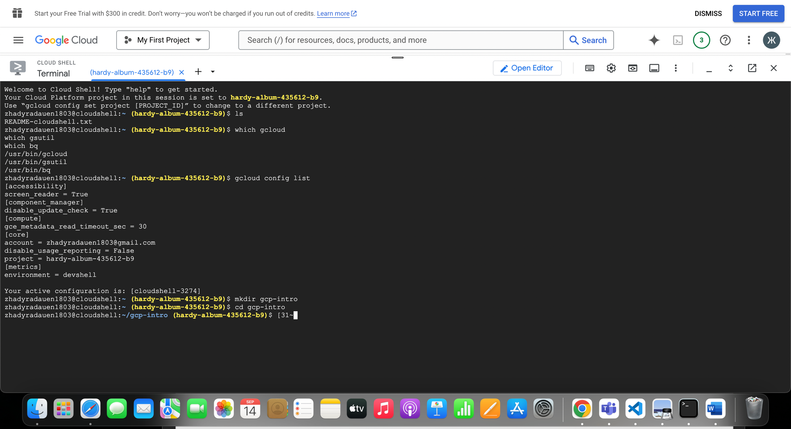○ Create a directory named gcp-intro and navigate into it.

○ Use the built-in code editor to create a simple README.md file describing your

GCP project.

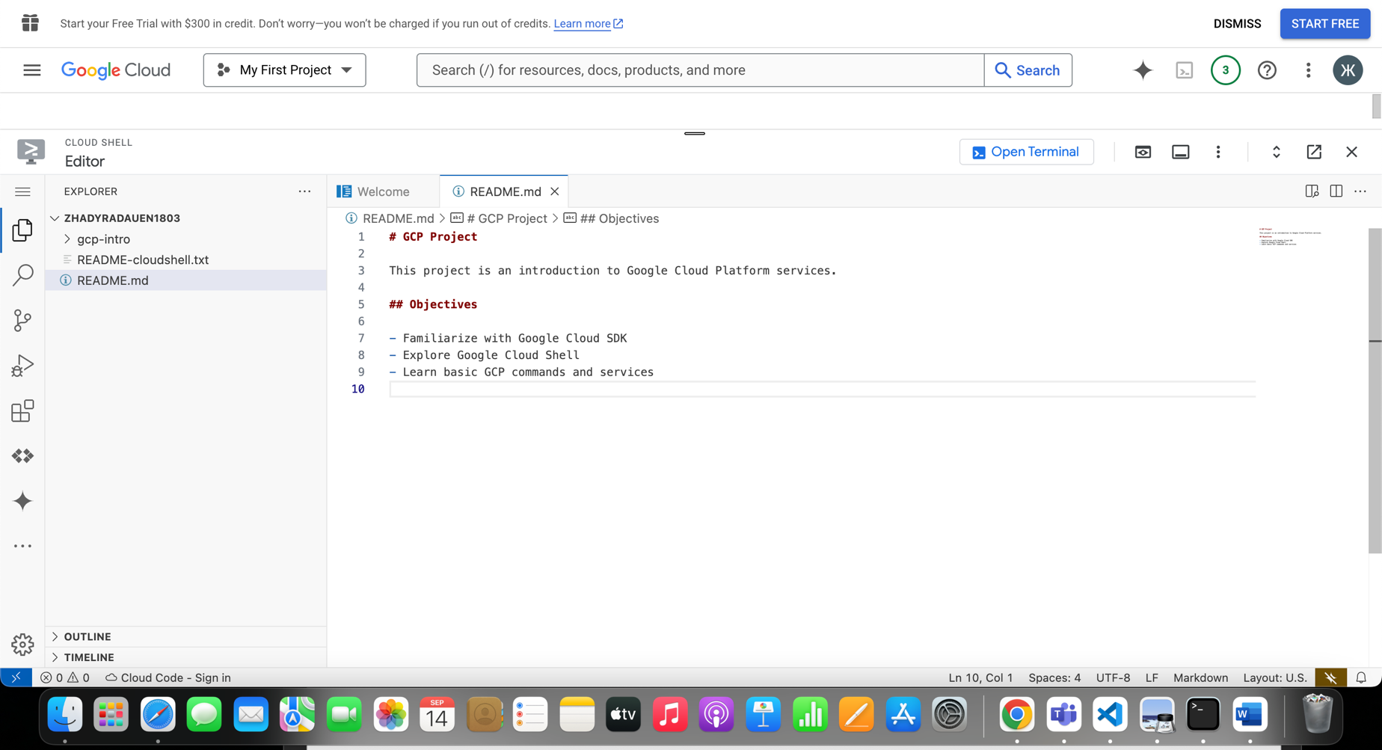

1. **Questions**:
   1. What is the default home directory in Cloud Shell?

In Cloud Shell, the default home directory is typically `/home/your-username` or simply `~`. When you start a Cloud Shell session, you are placed in this directory by default. It's where you can store your files and configurations specific to your Cloud Shell environment.

○ What tools are pre-installed in Cloud Shell?

The VM is pre-installed with cloud management tools and system tools, including Python, Java, Node.js, Alibaba Cloud CLI, cURL, SSH, Kubectl, Fun, Terraform, Ansible, and Vim.

○ How can you open the built-in code editor in Cloud Shell?

We can open the built-in code editor in Cloud Shell by clicking to the **"Open Editor"** button in the Cloud Shell toolbar. Or we use command code .

In the editor will be open Cloud Shell interface where you can create, edit, and manage files.

# Exercise 3: Managing Projects with Google Cloud SDK

1. **Objective**: Use Google Cloud SDK to manage projects.
2. **Steps**:
   1. List all the projects associated with your Google account using gcloud projects list.

○ Create a new project with the command gcloud projects create PROJECT_ID --name="My First GCP Project".

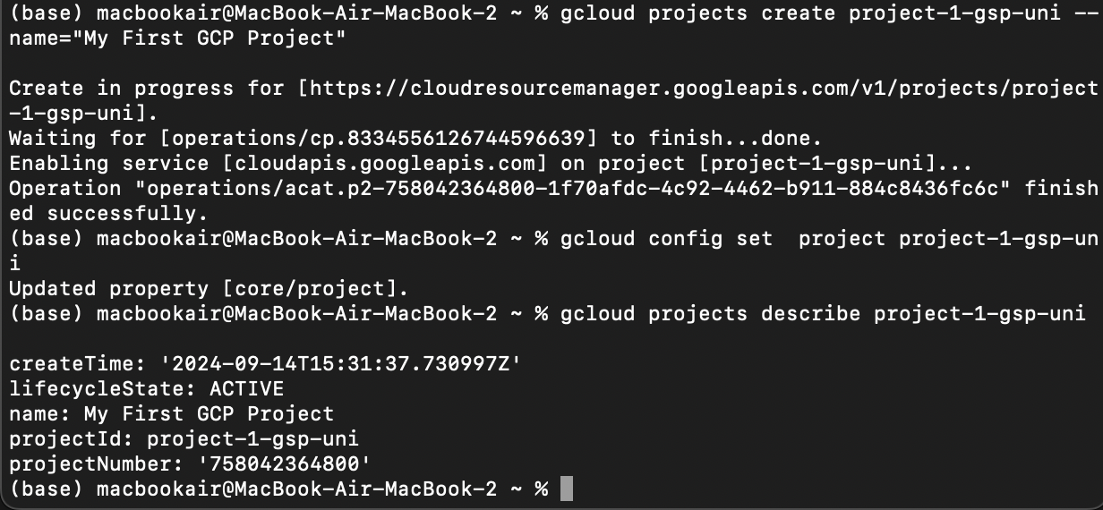

○ Set this new project as your default project.

○ Explore project metadata using gcloud projects describe PROJECT_ID.

○ Delete the project using gcloud projects delete PROJECT_ID after

completing the exercise.

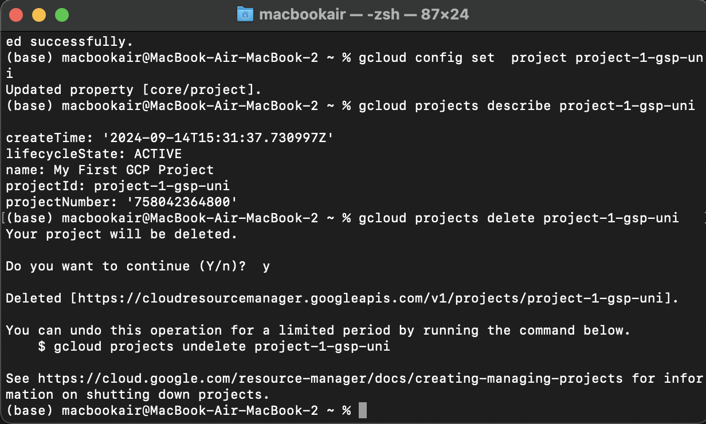

1. **Questions**:
   1. How do you list all projects associated with your account?

Used the command: gcloud projects list

○ What command is used to set a default project?

gcloud config set project project-1-gsp-uni

○ How do you describe project metadata?

gcloud projects describe project-1-gsp-uni

# Exercise 4: Using Cloud Shell for Basic Operations

1. **Objective**: Perform basic file and directory operations in Cloud Shell.
2. **Steps**:

○ In Cloud Shell, create a directory structure that mimics a small project (e.g., myproject/src, myproject/tests, myproject/docs).

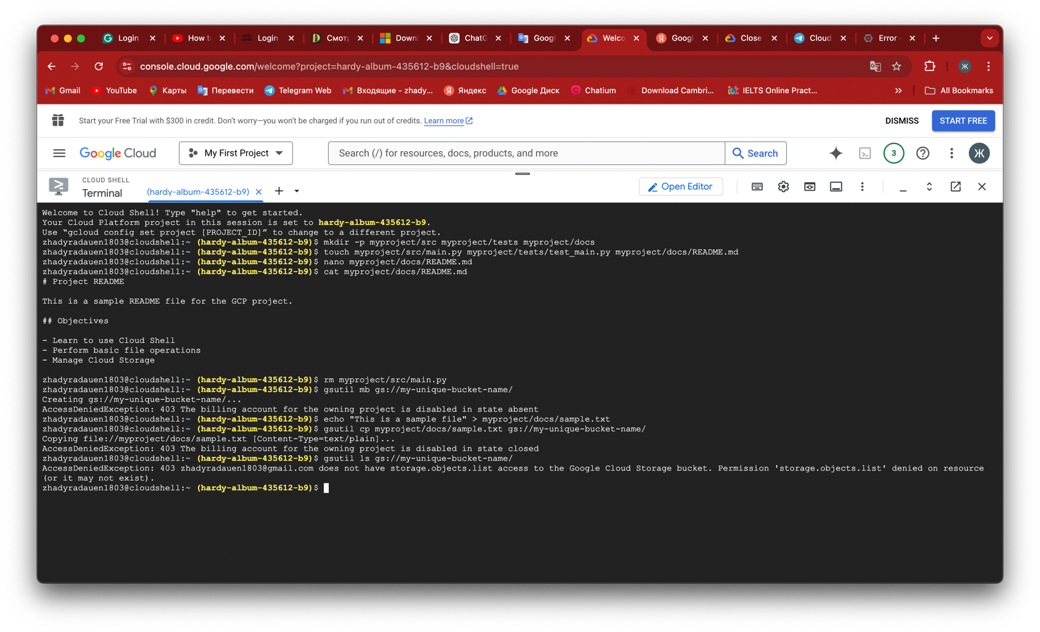

* 1. Create a few files in these directories and use commands like touch, nano, cat, and rm to manipulate them.

○ Use gsutil to create a new Cloud Storage bucket and upload a file from your

Cloud Shell environment.

○ Verify the file upload by listing the contents of the bucket.

Without an active billing account, I cannot create resources such as Cloud Storage buckets.

1. **Questions**:
   1. What command did you use to create the directory structure?

mkdir -p myproject/src myproject/tests myproject/docs

○ How did you upload a file to a Cloud Storage bucket?

gsutil cp myproject/docs/sample.txt gs://my-unique-bucket-name/

○ How can you list the contents of a Cloud Storage bucket?

gsutil ls gs://my-unique-bucket-name/

# Exercise 5: Automating Tasks with Shell Scripts in Cloud Shell

1. **Objective**: Write and execute a basic shell script in Cloud Shell.
2. **Steps**:

○ In Cloud Shell, create a new shell script named setup.sh in your gcp-intro directory.

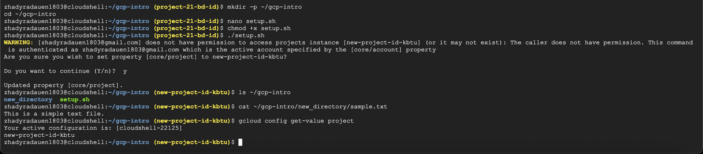

○ The script should automate the creation of a new directory, a simple text file, and set up a basic Google Cloud configuration (e.g., set a default project).

○ Make the script executable using chmod +x setup.sh.

○ Run the script and verify that it performs the expected tasks.

1. **Questions**:

○ What command did you use to make the script executable?

chmod +x setup.sh

○ How did you ensure the script was executed correctly?

To ensure the script executed correctly, check for the creation of the new directory and text file, verify the content of the text file, and confirm that the Google Cloud project configuration was updated.

○ What steps did your script automate?

The script automates the creation of a new directory named “new_directory” inside “~/gcp-intro”, creates a simple text file named `sample.txt` within the new directory containing a line of text, and sets the default Google Cloud project configuration.